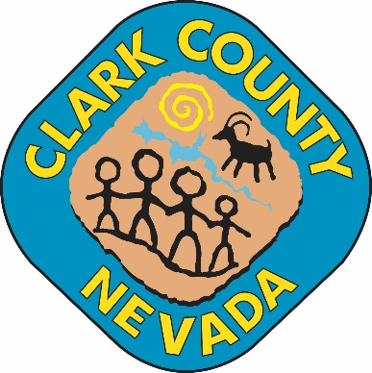

CERTIFICATE OF POSTING
I, the undersigned, do hereby certify that on this date, Click here to enter text., at (time), I posted in Click here to enter text. located at Click here to enter text. the agenda for the Open Meeting of:

Click here to enter text. | Click here to enter text.

_______________________________________
NAME
TITLE

_______________________________________
SIGNATURE

Please post the attached agenda in a public area of your building. NRS 241.020 mandates a written notice of all public meetings be posted no later than 9 a.m. three (3) working days before the meeting. NRS 241.020 (4) mandates that a certificate of posting be completed by each individual posting a copy of the public notice. The certificate of posting must include: (1) date and time of posting, (2) address of the location of posting, and (3) name, title, and signature of person who posts the public notice.
Please return this signed Certificate of Posting to: Official Clerk/Secretary of the Public Body.

