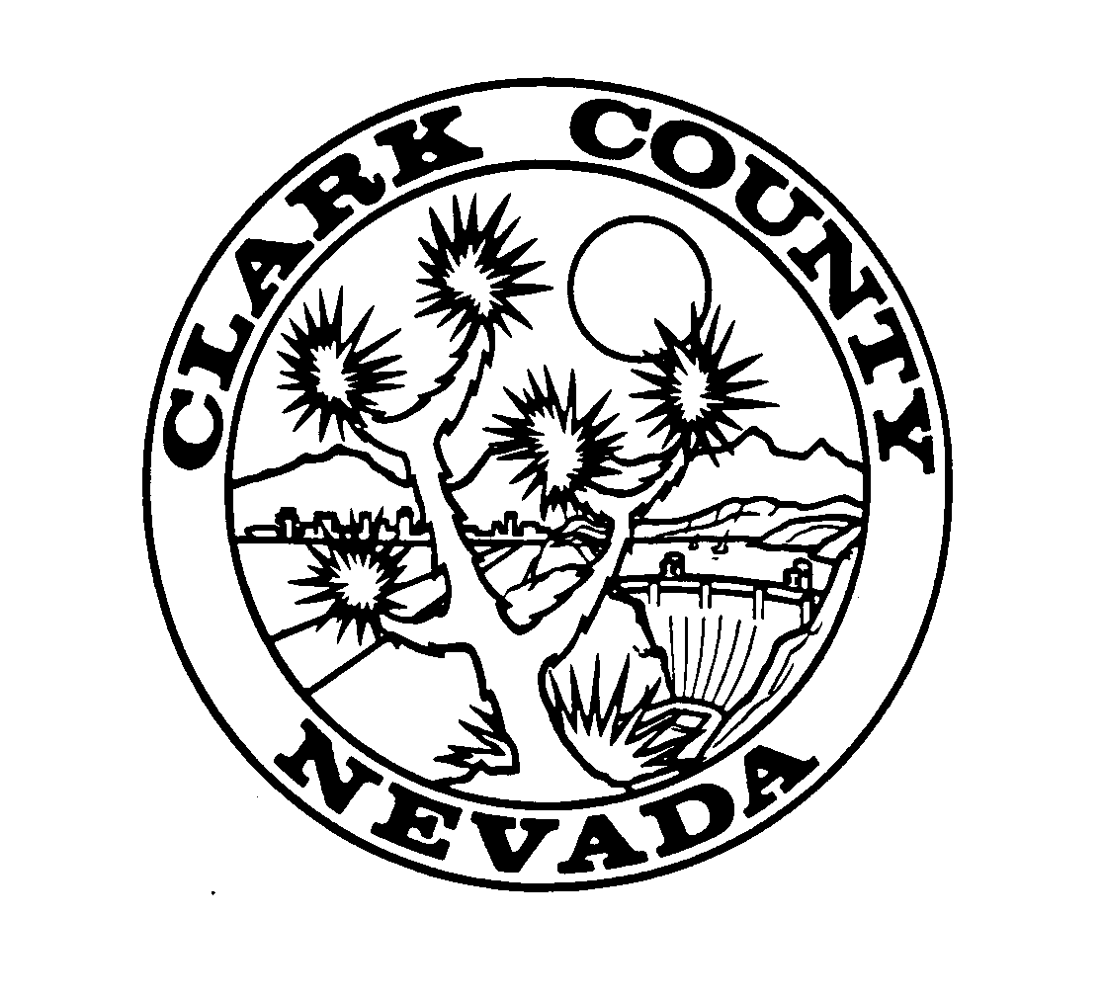
CLARK COUNTY COMPTROLLER’S OFFICE
Anna Danchik, Comptroller
500 S Grand Central Pkwy PO Box 551210
Las Vegas NV 89155-1210
ACH Direct Deposit
Enrollment Form
Office Use Only

Vendor #____________________

Regular Unity

Name & Mailing Address |  | Tax Identification Number  (Attach a completed W-9 form)
 |  | E-mail address (please print clearly)
Contact Name Daytime Phone

Name of Financial Institution:
(Item 3 below):
Name(s) on Account:
(Item 1 below):
Routing Number:  (Item 4 below) |  | Account Number:  (Item 5 below)
Please Credit:  (Select One) | Checking account  (attach voided check) |  | Savings account  (attach Routing & Account numbers)

I hereby authorize the Clark County Comptroller’s to deposit funds into my (our) account at the named financial institution for payment of accounts payable invoices/requests.

I understand and acknowledge the following:
- That I must notify Clark County Comptroller’s office of any changes of the contact person and e mail address.

- That I must notify the Comptroller’s Office in writing if I change financial institutions or if my account information changes.

- That the Direct Deposit will continue unless I notify the Comptroller’s Office in writing to discontinue the program.

- That if this deposit is rejected by my financial institution, I may be excluded from further participation in the Direct Deposit program.

____________________________________________________________ ___________________________________
Signature Date
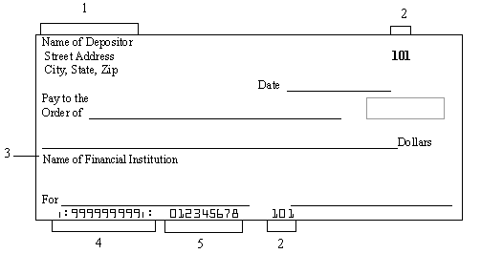
- Name(s) on account
- Check number
- Name of Financial Institution
- Routing number
- Account number

Please remember to sign above and attach voided check or savings deposit slip to form.

